Discussion questions for
If I Could Sit on a Bee’s Knees

- The cat is on almost every page. What pages do not have a cat?

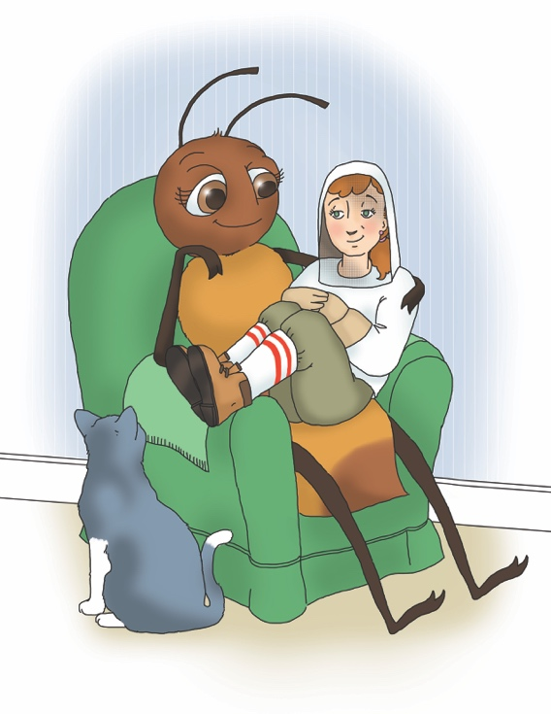
- The bee on the cover has only four legs showing, and no wings. Where do you think the other two legs might be? Where might her wings be?

- Do bees have knees?

- What other creatures have a proboscis?

- How should you act when you see a honey bee?

- What are the three kinds of bees in a hive?

- How do bees make the buzzing sound?

- Why do bees do the waggle dance?

- In the background photo on page 10, what might be happening with those things in the air?

- On page 11, there is a photo of two wasps and a honey bee. Which one is the wasp?

- The bee in the photo on page 23 has a yellowish ball on her back leg. What do you think it is?

- Bees have three distinct body areas—head, thorax and abdomen. Do you see them in the photographs and illustrations?

- Are the bees on page 18 worker bees, drones, or queen bees? Are the bees in the photo on page 17 worker bees, drones or queen bees?

- Why do beekeepers wear special suits?

- How can you help honey bees?

It is a photo of honey bees swarming.
The one in the middle.
Pollen in her pollen basket.
All worker bees.
Reduce use of lawn chemicals, plant native plants so pollinators have food sources, raise plants that bloom all season long so pollinators have food sources, buy honey from local beekeepers to support their efforts, learn more about bees!

