Vocabulary words for
If I Could Sit on a Bee’s Knees

Vocabulary words highlighted in the book, in alphabetical order:

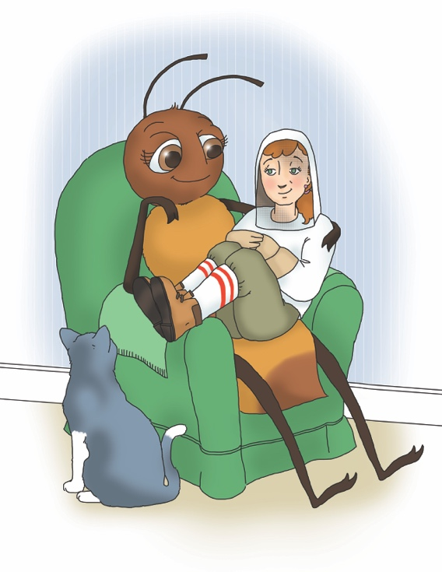
bumblebee
drones
hive
honey
honey bee
honey comb
nectar
pollen
pollination
proboscis
queen bee
swarm
trophallaxis
waggle dance
wasp
worker bees

Additional vocabulary words related to honey bees:

abdomen
antenna
apiary
beekeeper
beeswax
buzz
cluster
compound eyes
forewing
head
hindwing
honey stomach
hornets
legs
pollen basket
scout bees
simple eyes
smoker
stinger
thorax

